(Add a Project Title Here)
Science, Upward Bound – Summer 2017

Project Summary
In this section, write 2-4 sentences that summarize the project. Consider briefly discussing the reason and/or goal for the project, a quick description of the most interesting results, and an explanation of what the results mean.

Introduction
Anyone reading this report will need a certain level of background information that will help them understand the project results. Here is where you should discuss why water quality is important, and discuss why you are using test strips instead of other methods. You can also include information about the water samples or some of the contaminants, if you wish. There are a few websites listed in the oral presentation instructions that contain information about some of the tests and contaminants (and should be a good starting point). This section should be 2-3 paragraphs. Also, you should cite your reference sources. For example, if I find some information from a website, I need to let the reader know where I found it. The next sentence is an example, and the reference will need to be listed in the References section at the end of the report. Water quality is not just important to our individual health, it also helps us monitor water and make changes when something needs to be improved.¹
In the last paragraph, you should include a few hypotheses about what you might find in your experiment.

Methods
Now we get into the nitty-gritty details. When a fellow scientist reads this section, he or she should be able to reproduce your experiment with the details provided here. It is important to talk about all the materials you used, details about your water samples, and any special data analysis tools you might have used.

Results
The results of all three water samples should be included here. A table may be useful for displaying the results in an easy-to-read format. Graphs tend to be even better. Here, each student should include his or her individual results in a table, then provide the average results of all classes as a graph. The instructor will help you prepare the graph.
 | Missouri River | Tap Water | Bottled Water
pH
Alkalinity (mg/L)
Hardness (mg/L)
Iron (mg/L)
Copper (mg/L)
Lead (mg/L)
Nitrate (mg/L)
Nitrite (mg/L)
Chlorine (mg/L)
Table 1: This is where you should write a brief description of what is contained in this table. You may want to say that this is the collection of data from your group.

Now that you have reported your group’s data, we will compare our results to those of our classmates. You should have three graphs (one for each sample) that compares your results with everyone else’s. Some sample graphs are included here:
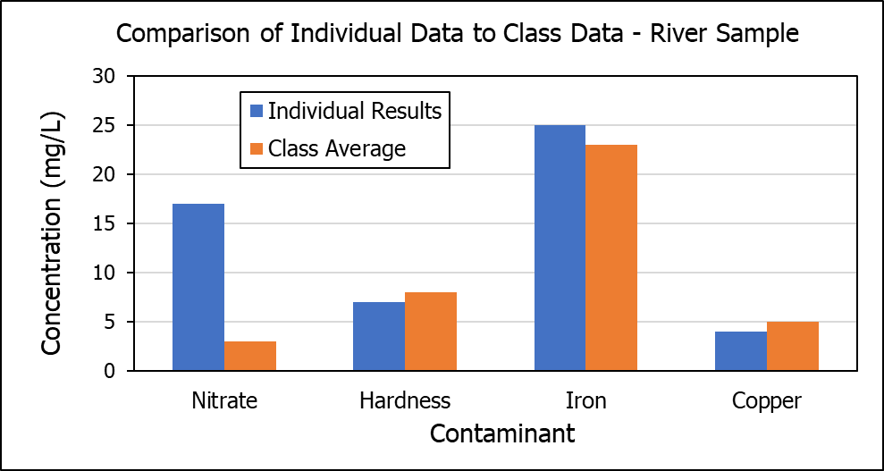
Figure 1: This is a description of the figure above. The description should include what sample the data is from and that you are comparing your data to the class average.
You should include some observations about these graphs in between, as you add them. For example, In the above graph, I see there is a significant difference between my results and the class results. I would use this opportunity to point this out.
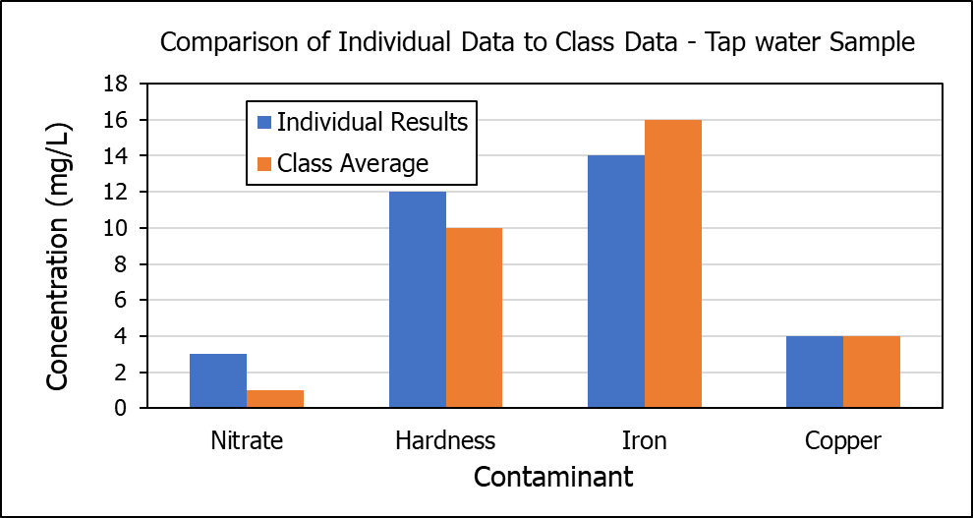
Figure 2: This is a description of the figure above. The description should include what sample the data is from and that you are comparing your data to the class average.

Again, this is an opportunity to discuss your observations of the data in Figure 2. This time, my data seems to match well with the class average.
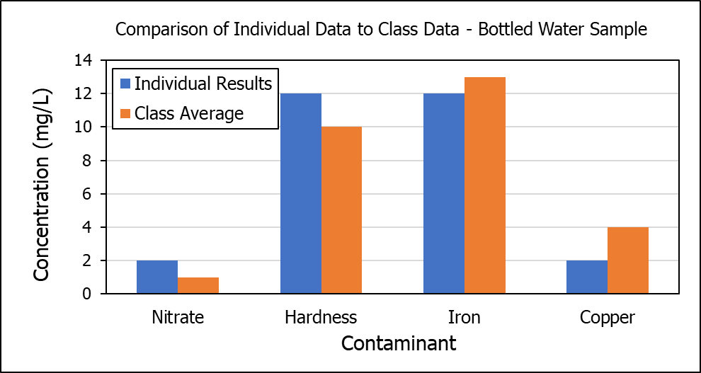
Figure 3: This is a description of the figure above. The description should include what sample the data is from and that you are comparing your data to the class average.

This is the last opportunity to provide your observations about the sample. Also, you can start to compare the three graphs. What values are similar and what values are different. For example, perhaps you see a number that is very similar among all graphs. Or maybe one that is very different. How does the data for river water compare to the data for the other two samples, which undergo treatment?

Conclusion
Now that we have looked at and compared all our data, we can try to figure out what it means. This section is where you could say things like “the river water sample was much cleaner than expected,” or “the bottled water sample had less contaminants than the river water.” You may also include statements like “the river water sample was high in nitrates, which may mean there is a farm upstream that uses fertilizer.” Are there contaminants that you found to be above recommended levels? If so, you could suggest a course of action, such as notifying the city council or other government representative. This section should be 1-2 paragraphs.

References
This section will include any sources you used when writing your introduction.
- United States Geological Service, https://water.usgs.gov/owq/WhyMonitorWaterQuality.pdf, Accessed 06/21/2017.

